
THE G8 EXAMINATION
Kenya Certificate of Secondary Education
FORM 4 TERM 2- JUNE 2026

232/1
Paper 1
Physics (Theory)
Time 2 hours

Name …………………………………………….……… Adm Number…………………Class……….
Candidate’s Signature ………………….…...………. Date ……………………………………
INSTRUCTIONS TO CANDIDATES: -
- Write your name, Admission number and class in the spaces provided above.
- This paper consists of two sections: A and B
- Answer all the questions in section A and B in the spaces provided
- All working must be clearly shown.
- Mathematical tables and electronic calculators may be used
- This paper consists of 13 printed pages. Candidates should check to ascertain that all pages are printed as indicated and that no questions are missing.
- Candidates should answer the questions in English.
For Examiner’s Use Only:

Section | Question | Maximum  Score | Candidate’s  Score
A | 1 – 11 | 25
 | 12 | 11
 | 13 | 08
 | 14 | 08
B | 15 | 09
 | 16 | 09
 | 17 | 10
Total Score |  | 80

TURN OVER
SECTION A (25 marks)
Answer all questions in this section in the spaces provided
- The diagram below shows the earth moving around the sun continually . State the branch of Physics that would be concerned with this. (1 mark)

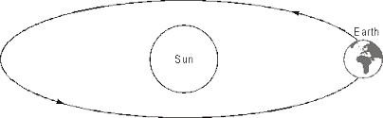

………………………………………………………………………………………………………………………………………………………………………………………………………………
- The diameter of a steel ball is measured using a vernier callipers which has divisions of 0.1cm on its main scale (MS) and 10 divisions of its vernier scale (VS) match 9 divisions on the main scale. Three such measurements for a ball are given as
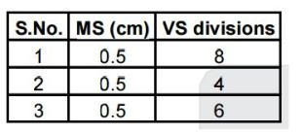
If the zero error is – 0.03 cm, calculate then mean corrected diameter of the steel ball. (3 marks)
………………………………………………………………………………………………………
………………………………………………………………………………………………………
………………………………………………………………………………………………………
………………………………………………………………………………………………………………………………………………………………………………………………………………

- A wooden block on a horizontal surface is pulled by a constant horizontal force T as shown in the diagram below, at two different sections. The block moves with constant velocity along XY. Section XYP is rough, while PQ is smooth. Use the information to answer questions that follow.

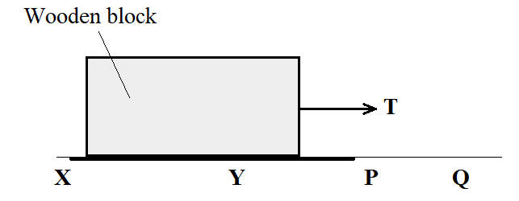

- Describe the motion of the block as it enters section PQ. (1 mark)
………………………………………………………………………………………………
………………………………………………………………………………………………
- Give a reason for your answer. (1 mark)
………………………………………………………………………………………………
………………………………………………………………………………………………
- Two identical well lagged cans A and B, each has equal volumes of water and are fitted with thermometers T_{A} and T_{B} as shown in the figure below. Water in A is at 45ºC, while water at B is at room temperature of 25ºC. Cold water is poured carefully in A and simultaneously, an equal mass of hot water is poured in B.
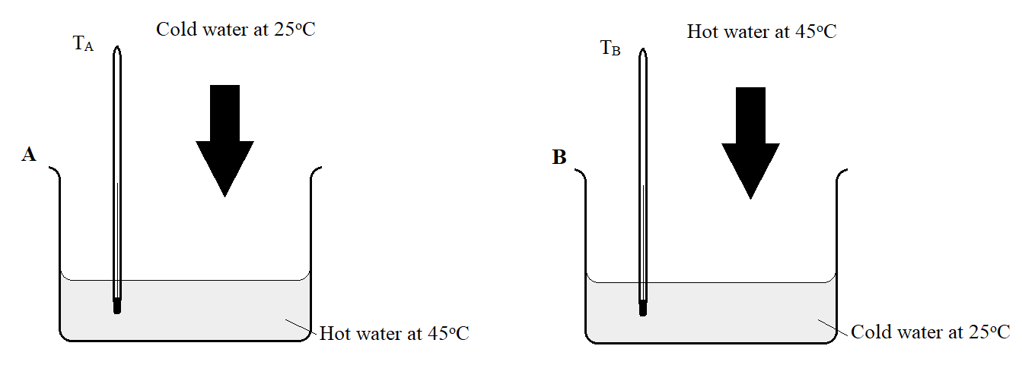
- State which of the thermometers record a lower reading after a short while (1 mark)
………………………………………………………………………………………………
- Give reason for your answer in (a) above (1 mark)
………………………………………………………………………………………………
………………………………………………………………………………………………
………………………………………………………………………………………………

- A stone of mass 200g is whirled on a vertical circle at constant speed of 3m/s, as shown in the diagram below.
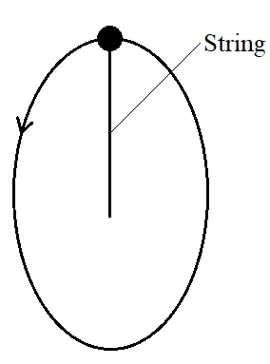
Determine the tension T in the string when the stone is at its uppermost point shown, given that the string is 40cm long. (3 marks)
………………………………………………………………………………………………………
………………………………………………………………………………………………………
- Below is a solid frustrum of a cone, resting on its narrow end on a horizontal flat surface. The solid is made of a uniform material.
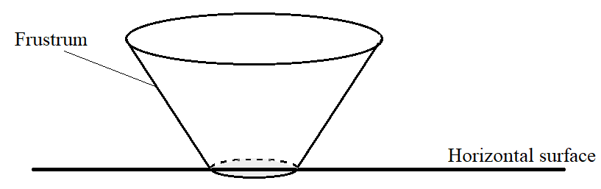
- Name the state of equilibrium of the solid on the surface. (1 mark)
………………………………………………………………………………………………
- Locate the centre of gravity of the cone, and mark it M (2 marks)

- Some pollen grains were placed in water to study Brownian motion in liquids. State and explain the nature of the observed motion. (2 marks)
………………………………………………………………………………………………………
………………………………………………………………………………………………………
………………………………………………………………………………………………………
………………………………………………………………………………………………………
- When estimating the diameter of an oil molecule, a student measured the diameter of an oil drop using vernier callipers. State the assumption she made in this measurement. (1 mark)
………………………………………………………………………………………………………

- A form one student at Upper Secondary School had a tin can half filled with water, as shown in the figure below.
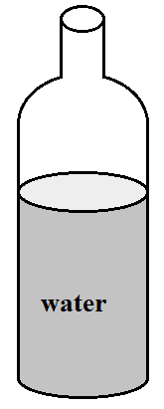
She heated the water and let it to boil for some time. The open top was then sealed, and cold water poured on the can. The can was observed to crash in. State why:
- The water was let to boil for some time. (1 mark)
………………………………………………………………………………………………
- Cold water was poured on the can. (1 mark)
………………………………………………………………………………………………
- Explain why the tin can crushed in (2 marks)
………………………………………………………………………………………………
- The temperature if a gas in a container of fixed volume was gradually lowered, and the corresponding pressure measured. Below, is a sketch graph showing the variation of pressure with temperature from the experiment.
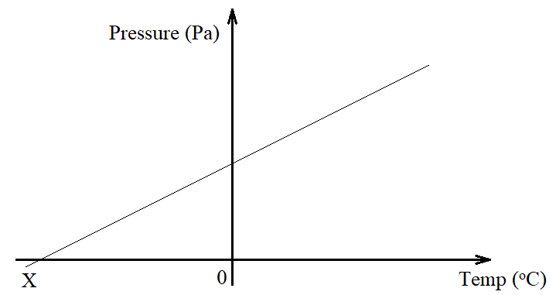

- Define temperature X using kinetic theory of matter (1 mark)
………………………………………………………………………………………………
………………………………………………………………………………………………

- State the reason why temperature X cannot be achieved (1 mark)
………………………………………………………………………………………………
………………………………………………………………………………………………
- A steel wire of length 20cm was coiled several times to make a spring. The spring was loaded with various weights and a graph of Force against extension plotted as indicated in Fig i below.
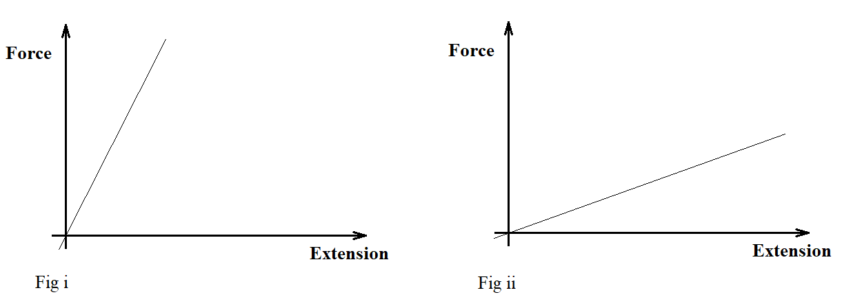
State any two changes that could be made on the spring to obtain the graph in Fig ii (2 marks)
………………………………………………………………………………………………………
………………………………………………………………………………………………………
SECTION B (55 marks)
Answer all the questions in this section in the spaces provided

- State Bernoulli’s principle. (1 mark)
………………………………………………………………………………………………
………………………………………………………………………………………………
………………………………………………………………………………………………
- In deriving the equation of continuity, it is assumed that the fluid is non-viscous. Explain the effect of increase in fluid viscosity on the type of flow. (2 marks)
………………………………………………………………………………………………
………………………………………………………………………………………………
………………………………………………………………………………………………
………………………………………………………………………………………………

- The figure below shows water in a horizontal tube of two different sections, AB and BC.
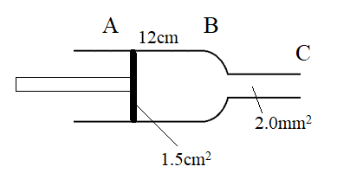
The cross-sectional area on the piston is 1.5cm² while that of section BC is 2.0mm². If the piston moves 12cm from A to B in 3 seconds, calculate:
- The volume flux of water (3 marks)

- The speed of water through section BC (2 marks)

- Below is a cross-sectional diagram of a carburettor used to supply petrol for combustion in a car engine
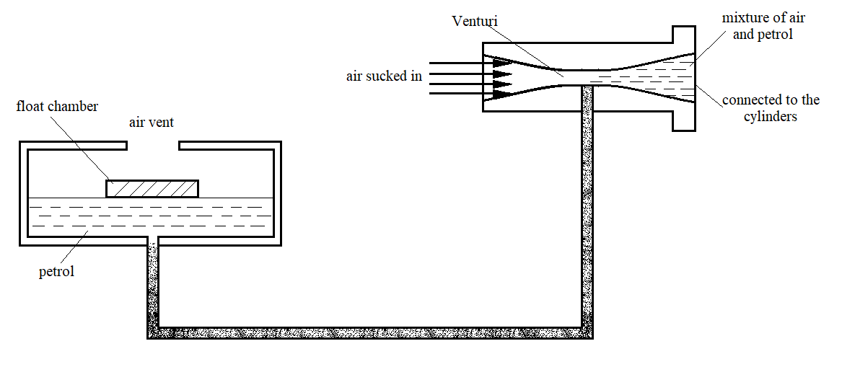
Explain how this carburettor is able to draw petrol into the combustion cylinders (3 marks)
………………………………………………………………………………………………
………………………………………………………………………………………………
………………………………………………………………………………………………

- A covid vaccine is only suitable when stored at a temperature of -40ºC. A nurse had a choice of measuring the temperature of this vaccine using either a mercury thermometer or an alcohol thermometer. Explain which of the two thermometers would be suitable. (1 mark)
………………………………………………………………………………………………
………………………………………………………………………………………………
- Below is a glass flask fitted with a tube and inverted in water.
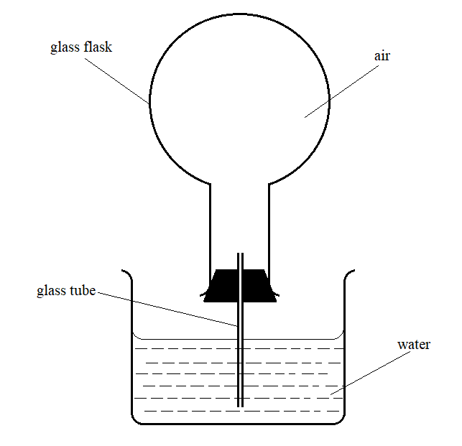
The temperature of the surrounding is slowly lowered.
- State the observation on the liquid level in the glass tube (1 mark)
………………………………………………………………………………………………
………………………………………………………………………………………………
- Give a reason for the above observation (2 marks)
………………………………………………………………………………………………
………………………………………………………………………………………………
- You have been provided with the following apparatus:
A glass bulb filled with mercury fitted onto a hollow stem, ice, boiling water in a can and a grid of equal squares. Use this apparatus to describe an experiment to make a graduated thermometer whose scale is in Celsius. (4 marks)
………………………………………………………………………………………………
………………………………………………………………………………………………
………………………………………………………………………………………………
………………………………………………………………………………………………

- Define velocity ratio as used in machines (1 mark)
………………………………………………………………………………………………
………………………………………………………………………………………………
- The figure below shows a load of mass 20kg being pulled up an inclined plane with a constant force of 150N. The plane makes an angle of 32ºC with the horizontal, and a height of 3m.
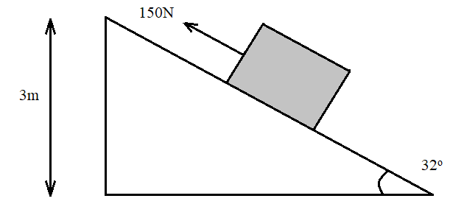
Determine:
- The work done on the load (2 marks)

- Work done by the effort (2 marks)

- The efficiency of the system (2 marks)

- The work done against the friction between the plane and the block (1 mark)
………………………………………………………………………………………………
………………………………………………………………………………………………

- Distinguish between heat capacity and latent heat of fusion of a substance (1 mark)
………………………………………………………………………………………………
………………………………………………………………………………………………
………………………………………………………………………………………………
………………………………………………………………………………………………
- Below is a figure showing a common refrigerator used for domestic purposes. A volatile liquid circulates in the capillary tubes.
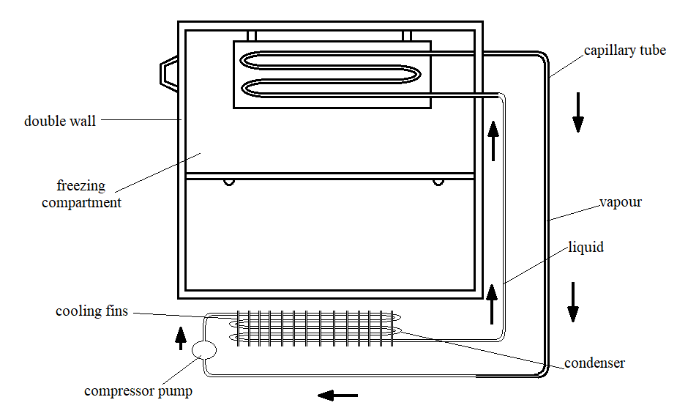
- State the reason why the diameter of the capillary tube is made wider at the freezing compartment. (1 mark)
………………………………………………………………………………………………
………………………………………………………………………………………………
………………………………………………………………………………………………
- Explain the function of the compression pump. (2 marks)
………………………………………………………………………………………………
………………………………………………………………………………………………
………………………………………………………………………………………………
………………………………………………………………………………………………
- Give a reason why food items are placed below the widened copper tube (1 mark)
………………………………………………………………………………………………
………………………………………………………………………………………………
- In an experiment to determine specific latent heat of vaporization of water, steam of mass 12g at 100ºC was passed into 80g of water initially at 23ºC in a container of negligible heat capacity. The temperature of water rises by 74K. Use the information to determine specific latent heat of vaporization of water (take specific heat capacity of water as 4.2kJ/kg/K and boiling point of water as 100ºC). (4 marks)
………………………………………………………………………………………………
………………………………………………………………………………………………
………………………………………………………………………………………………
………………………………………………………………………………………………

- The figure below shows a weighing balance on which a beaker containing some water is placed. The reading of the weighing balance and the spring balance are initially 2.80N and 2.70N respectively.
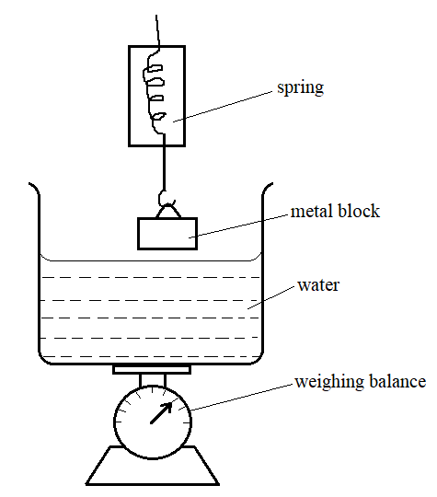
- The metal block is gradually lowered into water. State the observation made on:
- The spring balance reading (2 marks)
………………………………………………………………………………………………
………………………………………………………………………………………………
- The weighing balance reading
………………………………………………………………………………………………
………………………………………………………………………………………………
- The reading of the spring balance when the block is fully submerged in water is 2.36N. Determine the:
- Reading of the weighing balance (2 marks)
………………………………………………………………………………………………
………………………………………………………………………………………………

- The density of the stone (2 marks)
………………………………………………………………………………………………
………………………………………………………………………………………………

- Below is a figure showing a hydrometer floating in water.
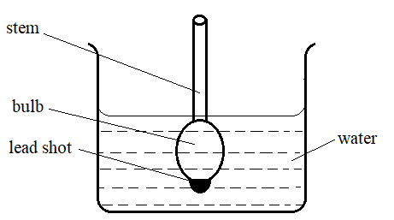
- State the function of the following: (2 marks)
- Wide bulb
…………………………………………………………………………………………..
…………………………………………………………………………………………..
- Lead shot
…………………………………………………………………………………………..
…………………………………………………………………………………………..
- Salt solution is added to the water. State the observation made on the hydrometer. (1 mark)
………………………………………………………………………………………………
………………………………………………………………………………………………
- A metal ball of mass 20kg at rest is pulled by a force and moves along a horizontal friction compensated table as shown below. The pull is withdrawn when the ball is at P after travelling 16 seconds from Q.
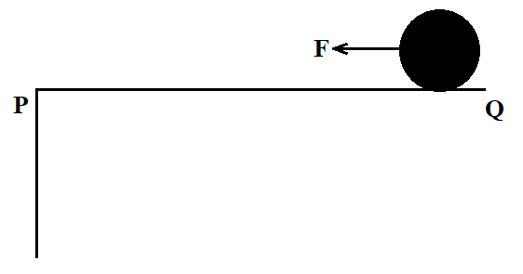
Below is a velocity-time graph for the motion of the ball as it moves along the tabletop.
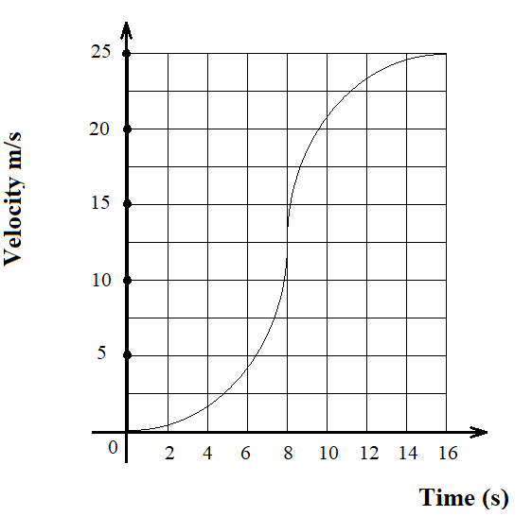
- Determine the distance PQ travelled along the tabletop. (3 marks)
………………………………………………………………………………………………
………………………………………………………………………………………………
………………………………………………………………………………………………
………………………………………………………………………………………………
- Calculate:
- The average acceleration between time t = 8 seconds and t = 16 seconds (2 marks)
………………………………………………………………………………………………
………………………………………………………………………………………………
- The average force acting between t = 8s and t = 16s. (2 marks)
………………………………………………………………………………………………
………………………………………………………………………………………………
- From P the ball falls to the ground a distance 22.5m from the foot of the table. Calculate the height of the table. (3 marks)
………………………………………………………………………………………………
………………………………………………………………………………………………
………………………………………………………………………………………………THIS IS THE LAST PRINTED PAGE

